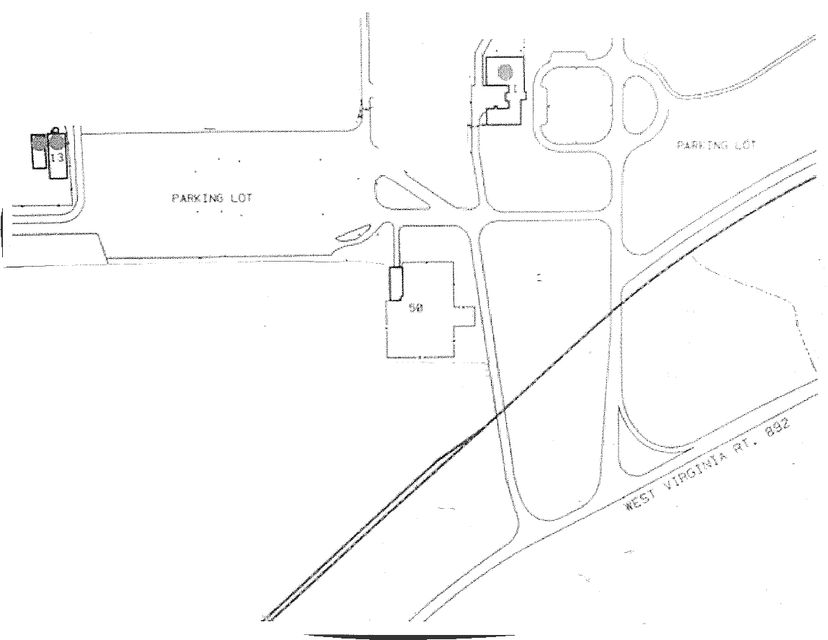

8480 DuPont Rd.

Washington, WV 26181

4

3

2

1

**1.** Before light, veer right into main entrance of plant

**2.** Cross train tracks and take first left

**3.** Follow to end of long parking lot and park

Contract Administration (Building 13) is located at end of parking lot and is clearly marked on wooden deck

**4.** Enter double doors, sign in, and let security know that you are here to see On-Board

CSX Railroad Tracks

Main Gate